



**DOKUMENTASI TEKNIS**

**CAPSTONE PROJECT – BIDANG PENDIDIKAN**

**Disusun Oleh:**

**DHIVA PUTRA SETIADJI**

**175120401111002**

**Kelas CF-004**

**HUBUNGAN INTERNASIONAL**

**UNIVERSITAS BRAWIJAYA**

**2021**

**CAPSTONE PROJECT**

***Capstone Project*** adalah sebuah proses pembelajaran berbasis proyek yang mendorong mahasiswa menerapkan apa yang sudah dipelajari pada program studi Independen. ***Capstone Project*** memberi kebebasan bagi mahasiswa untuk menyelesaikan masalah yang ada dengan pendekatan yang benar dan terstruktur. ***Capstone Project*** pada pembelajaran program studi independen dilaksanakan secara mandiri tanpa mengabaikan aspek pembimbingan dalam mengerjakannya. Pendekatan yang benar dan terstruktur adalah pendekatan yang memperhatikan banyak aspek dengan mempertimbangkan tiga hal:

1. Inovasi dan kreativitas dalam menyelesaikan masalah berdasarkan pengetahuan yang dimiliki
2. Batasan dan ruang lingkup seperti Batasan waktu, biaya, dan sumber daya sehingga menyelesaikan masalah secara efektif dan efisien.
3. Memiliki kontribusi praktis dengan tetap mempertimbangkan aspek lingkungan, pengembangan profesi, dan etika dalam pengerjaannya.

Tema ***Capstone Project*** terbagi menjadi tiga bidang pendidikan, kesehatan, dan juga bisnis. Mahasiswa hanya dapat memilih satu bidang sesuai dengan jalur yang diikuti. Perusahaan yang disebut dalam tema proyek ini adalah fiktif dan hanya merupakan contoh. Segala kebetulan dan kesamaan penamaan merk adalah kebetulan semata. Penulis memilih bidang Pendidikan sesuai dengan *Learning Track – Cloud Fundamental* yang saya ambil. Berikut solusi teknis yang harus disediakan pada Bidang Pendidikan – Cloud Fundamental:

MariBelajar adalah sebuah startup di bidang pendidikan. MariBelajar berfokus pada bidang pendidikan berbasis teknologi informasi khususnya teknologi Microsoft. Barubaru ini MariBelajar akan mengembangkan sebuah learning management system yang menyimpan semua materi dan dokumentasi kegiatan belajar mengajar MariBelajar.

**Solusi Teknis yang diharapkan**

Landing page yang dikembangkan akan menggunakan kapabilitas Azure. Misi anda adalah menyiapkan infrastruktur dan merancang infrastruktur serta proof of concept yang dapat diakses oleh manajemen MariBelajar. Solusi teknis memenuhi kemampuan sebagai berikut:

1. Menyiapkan solusi teknis berupa aplikasi web yang diperoleh dari Azure Marketplace atau diunggah secara mandiri.
2. Solusi teknis berupa aplikasi yang mendukung proses manajemen materi ajar seperti OpenEdx, Moodle, atau yang serupa
3. Solusi teknis dihosting dalam bentuk VM atau Azure Website
4. Solusi teknis sudah memiliki DNS dan dikonfigurasikan yang bisa diakses melalui alamat web
5. Solusi teknis dipasangkan dengan mempertimbangkan ***Well-Architected Framework***
6. Jika terdapat konfigurasi atau skrip atau kode sumber yang digunakan maka disimpan dalam Github

Luaran yang diharapkan

1. Pekerjaan dilakukan secara mandiri
2. Solusi bersifat terbuka berdasar kreativitas masing-masing individu
3. Video dokumentasi berdurasi maksimum 15 menit. Video dokumentasi dapat berupa kombinasi presentasi dan demonstrasi. Unggah video ke dalam Microsoft 8 Stream. Petunjuk untuk memulai menggunakan Microsoft Stream dapat diakses melalui Explore Stream (microsoft.com) dan petunjuk unggah video di Microsoft Stream dapat diakses melalui Upload your first video (microsoft.com).
4. Semua skrip, template, dan dokumentasi teknis dikirimkan melalui https://go.maribelajar.org/capstone-project dalam bentuk URL github.
5. Batas pengumpulan hasil capstone project adalah 30 November 2021 pkl. 23.59 WIB.

Berdasarkan hal tersebut, penulis telah menentukan apa saja solusi teknis yang akan digunakan penulis yaitu:

1. Penulis akan menyediakan solusi teknis berupa aplikasi melalui Azure Marketplace
2. Solusi Teknis yaitu adalah sebuah aplikasi yang mendukung proses managemen yaitu Bitnami LMS Powered by Moodle**TM** LMS
3. Solusi teknis nantinya akan dihosting dalam bentuk Virtual Machine
4. Solusi teknis akan disetting DNS dan SSL melalui Azure DNS Name Records, DNS Provider – Niagahoster dan SSL melalui CloudFlare atau melalui ComodoPositive SSL
5. Solusi teknis dipasangkan dengan mempertimbangkan Azure Well-Architected Framework.

**LANGKAH-LANGKAH DEPLOYMENT RESOURCE**

***“BITNAMI LMS POWERED BY MOODLETM LMS”***

**STEP 1:**

**PREREQUISITES (Persyaratan Awal)**

* Memiliki **Azure Subscription** terlebih dahulu. Azure menawarkan Azure Subscription yang dapat digunakan oleh user diantaranya adalah:
* via ***Azure Free Student*** ($100 for 12 months) = <https://azure.microsoft.com/en-us/free/students/>
* via ***GitHub Student Developer Pack*** = <https://education.github.com/pack> - Login using ***Federated Authentication*** using GitHub
* via ***Azure Free Account*** – ($200 for 30 days but Azure Services can be used for 12 months – required CreditCard . = <https://azure.microsoft.com/en-us/free/>
* via ***Azure Enterprise Agreement*** = <https://azure.microsoft.com/en-us/offers/enterprise-agreement-support/>
* via ***Pay-As-You-Go*** = <https://azure.microsoft.com/en-us/offers/ms-azr-0003p/>

**STEP 2:**

**DEPLOY VIRTUAL MACHINE “BITNAMI LMS POWERED BY MOODLETM LMS” MELALUI AZURE PORTAL**

* Log-In ke **Azure Portal. 🡪** <https://portal.azure.com>
* Tampilan ‘Home’ dari Azure Portal akan muncul
* Pilih “*Create a Resource*” – Ketik di pencarian *services* dan *marketplac*e “Bitnami Moodle”
* Pilih Bitnami LMS Powered by Moodle**TM** LMS – Virtual Machine – *Software Plan Starts at Free 🡪* Klik “Create”
* Follow Azure Recommendation for Well-Architectured Framework. Untuk Konfigurasi dapat dilihat dibawah ini:

**Azure Recommendation – Configuration Create VM – Bitnami LMS Powered by MoodleTM LMS**

|  |  |
| --- | --- |
| **BASIC** | |
| **Project Details** | Select the subscription to manage deployed resources and costs. Use resource groups like folders to organize and manage all your resources. |
| Subcription | You can pick Azure for Student, Pay As You Go, Depend your Subcription. (the subscription that should be billed for VM Hours) |
| *Resource Group* | If you have resource group before you create you can use it.  But here I’m gonna **Create new** with name **“MariBelajar-RG”** |
| **Instance Details** |  |
| Virtual Machine Name | Enter a name for your VM, such as **MariBelajar-VM** |
| Region | Select a Region Close to you from the Global Regions listed in the Following Table. I choose “East US” – because I use VPN to hidden my IP Address or I choose **“Southeast Asia”** because near with my Audience. |
| Availability Options | Accept default No infrastructure redundancy required. This option is used to ensure the VM is highly available by grouping multiple VMs together to deal with planned or unplanned maintenance events or outages. |
| Security Type | * Standard = the basic level of security for your virtual machines * Trusted launch virtual machines = Protects against persistent and advanced attacks on Gen 2 virtual machines with configurable features like secure boot and virtual Trusted platform Module (vTPM). 🡪 I Choose **Standard** |
| Image | Select **- Bitnami LMS powered by Moodle LMS – Gen 1** from the dropdown list. |
| Azure Spot Instance | Accept default (unchecked). |
| Size | The **Size** field is not directly editable. Select or accept the default **Standard_B2s**, which will give the 2 VCPU and 4 GB of memory. Optionally, select the field to view recommended or recently chosen sizes; select **See all sizes** to explore filters for sizes based on vCPUs, RAM, Data disks, operations per second, and cost. Select the X in the top right of the pane to close the pane. 🡪 **IDR 474,955.52/month 🡪 Cost Optimization** |
| **Administrator Account** |  |
| Authentication Type | Choose **“Password’** – If you want used SSH you can use SSH. |
| Username | Enter a username you will use to sign in to the VM. |
| Password | Enter a password that's at least 12 characters long and has at least three of the following four characteristics: one lower case character, one uppercase character, one number, and one special character that is not '\' or '-'. Use something you will remember or write it down, as you will need it later. |
| Confirm | Confirm your Password |
| **DISKS** | |
| **Disk Options** |  |
| OS Disk Type | Accept the default **Premium SSD (locally redundant storage)**. |
| Encryption Type | Accept the default **(Default) Encryption at-rest with a platform-managed key**. |
| Enable Ultra Disk compatibility | Accept default (unchecked) |
| **Data Disk** | You can add and configure additional data disks for your virtual machine or attach existing disks. This VM also comes with a temporary disk. I’m gonna choose Default not using New Disk |
| **Advanced** |  |
| Use managed disks | Default (checked) |
| Ephemeral OS Disk | Default ‘none’ |
| **NETWORK** | |
| **Network Interface** | When creating a virtual machine, a network interface will be created for you. |
| Virtual network | Default (name your vm-vnet) but you can create new  Configuration :  Name = depend what you want must global unique name  Address Space = The virtual network's address space, specified as one or more address prefixes in CIDR notation (e.g. 192.168.1.0/24).  --- Address Range = Select the checkbox in the row below the heading, and enter e.g.172.16.0.0/16 to give the address space a full range of addresses. If another address range row exists, select it to delete it.  Subnets = The subnet's address range in CIDR notation. It must be contained by the address space of the virtual network.  --- subnet name = Select the checkbox in the row below the heading, and enter default in the first input field. If another row exists, select it to delete it. |
| Subnet | Default (default (e.g. 172.16.0.0/16)) – but First subnet to subdivide the address space - it must fit within the defined address space. After the VNet is created, you can add more subnets. |
| Public IP | Overall IPV4 space available to this network. |
| NIC Network security group | Default ‘Advanced’ |
| Configure Network Security Group | Default (Automatically Your VM-NSG). But if you don’t use it, you can create new |
| Accelerated Networking | Default (Unchecked) |
| **Load Balancing** | You can place this virtual machine in the backend pool of an existing Azure load balancing solution. |
| Place this virtual machine behind an existing load balancing solution? | Default (Unchecked) |
| **MANAGEMENT** | |
| **Azure Security Center** | Azure Security Center provides unified security management and advanced threat protection across hybrid cloud workloads   * Your plan based on Your Subcription – My Subcription using Azure Free Student, so My Azure Security center is Basic Plan |
| **Monitoring** |  |
| Boot Diagnostics | Default (**Enable with managed storage account**) – recommended |
| Enable OS guest Diagnostics | Default (unchecked) |
| **Identity** |  |
| System Assigned Managed Identity | Default (unchecked) |
| **Azure AD** |  |
| Login with Azure AD (Preview) | Default (unchecked) |
| **Auto-Shutdown** |  |
| Enable Auto Shutdown | Default (unchecked) |
| **Backup** |  |
| Enable Backup | Default (unchecked) |
| **Guest OS Updates** |  |
| Patch Orchestration Options | Image Default. Not all Patch Orchestration does support with all image what you use in Basics |
| **ADVANCED** | |
| **Extensions** | Extensions provide post-deployment configuration and automation. |
| Extensions | Select and Extension to Install. I’m not using Extension for this one |
| **VM Applications** | VM applications contain application files that are securely and reliably downloaded on your VM after deployment. In addition to the application files, an install and uninstall script are included in the application. You can easily add or remove applications on your VM after create. |
| VM Application to Install | Select a VM Application to Install. I’m not using VM Application for this one too. |
| **Custom Data and Cloud Init** | Pass a cloud-init script, configuration file, or other data into the virtual machine while it is being provisioned. The data will be saved on the VM in a known location. |
| Custom Data | Default (Empty) |
| **User Data** | Pass a script, configuration file, or other data that will be accessible to your applications **throughout the lifetime of the virtual machine**. Don't use user data for storing your secrets or passwords. |
| Enable User Data | Default (unchecked) |
| **Host** | Azure Dedicated Hosts allow you to provision and manage a physical server within our data centers that are dedicated to your Azure subscription. A dedicated host gives you assurance that only VMs from your subscription are on the host, flexibility to choose VMs from your subscription that will be provisioned on the host, and the control of platform maintenance at the level of the host |
| Host Group | No Host Group Found |
| **Proximity Placement Group** | Proximity placement groups allow you to group Azure resources physically closer together in the same region |
| Proximity Placement Group | Default (No Proximity Placement Groups Found) |
| **TAGS** | |
| **Tags** | Tags are name/value pairs that enable you to categorize resources and view consolidated billing by applying the same tag to multiple resources and resource groups.  Note that if you create tags and then change resource settings on other tabs, your tags will be automatically updated.  Name : I’m gonna type “Name = MariBelajar, Value= Learning Management System’ |
| **REVIEW AND CREATE** | |
| **Terms** | By clicking "Create", I (a) agree to the legal terms and privacy statement(s) associated with the Marketplace offering(s) listed above; (b) authorize Microsoft to bill my current payment method for the fees associated with the offering(s), with the same billing frequency as my Azure subscription; and (c) agree that Microsoft may share my contact, usage and transactional information with the provider(s) of the offering(s) for support, billing and other transactional activities. Microsoft does not provide rights for third-party offerings. See the Azure Marketplace Terms for additional details.  Name = Your Name  Prefereed Email Address = your Email  Preferred Phone Number = Your Phone Number |
| IF VALIDATION PASSED, YOU CAN CREATE NOW. IF NOT, REVIEW AGAIN, IF SOMETHING WRONG. | |
| **CREATE** | |

**STEP 3:**

**AFTER BITNAMI LMS POWERED BY MOODLE LMS DEPLOYMENT WAS COMPLETED.**

* Klik “Go to Resource”
* Halaman Overview “MariBelajar-VM” akan muncul

Terdapat beberapa settingan yang harus dilakukan sebelum membuka VM melalui IP Public Address:

1. Mengubah **“Public IP Adress Assignment”** dari “Dynamic” ke “Static”.

* Dari Halaman Overview “MariBelajar-VM” – Klik “DNS – Not Configured”
* Akan ditampilkan halaman dari “MariBelajar-VM-ip”
* Ubah “**IP Address Assignment”** dari “Dynamic” ke “Static”
* Serta tambahkan DNS Name Label sesuai dengan yang kamu inginkan, Link DNS akan seperti ini *maribelajar.eastus.cloudapp.azure.com*.
* Kembali ke Halaman Overview “MariBelajar-VM” dan Klik ‘Refresh’

1. Memastikan Status “Running” di Bitnami dari VM melalui “Run as Administrator” Command Prompt

* Buka “Windows Search” dan ketikkan “Command Prompt”
* Klik kanan dan pilih “Run as Administrator”
* 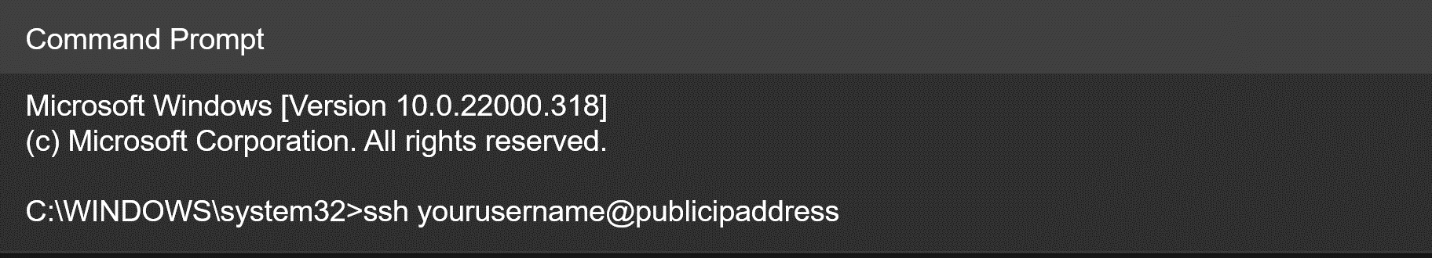Masukkan Konfigurasi untuk terhubung dengan VM kita melalui SSH

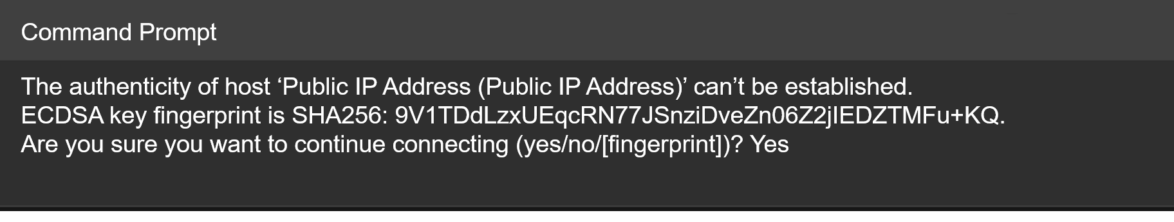Klik, Enter

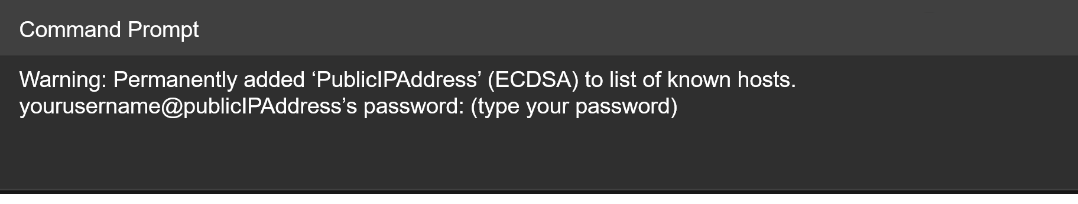Klik, Enter

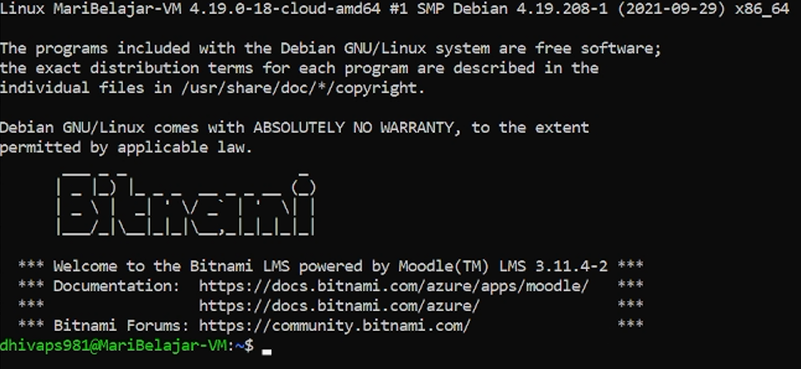Klik, Enter

Jika muncul seperti ini, maka dapat disimpulkan bahwa Virtual Machine sudah ‘Running’ dan dapat berjalan. Untuk memastikannya kembali, kalian dapat melakukan *“copy paste”* pada Public IP Address dan melakukan Paste di Browser anda. Tampilan Moodle Home akan muncul dan siap digunakan. Tampilan akan seperti ini:

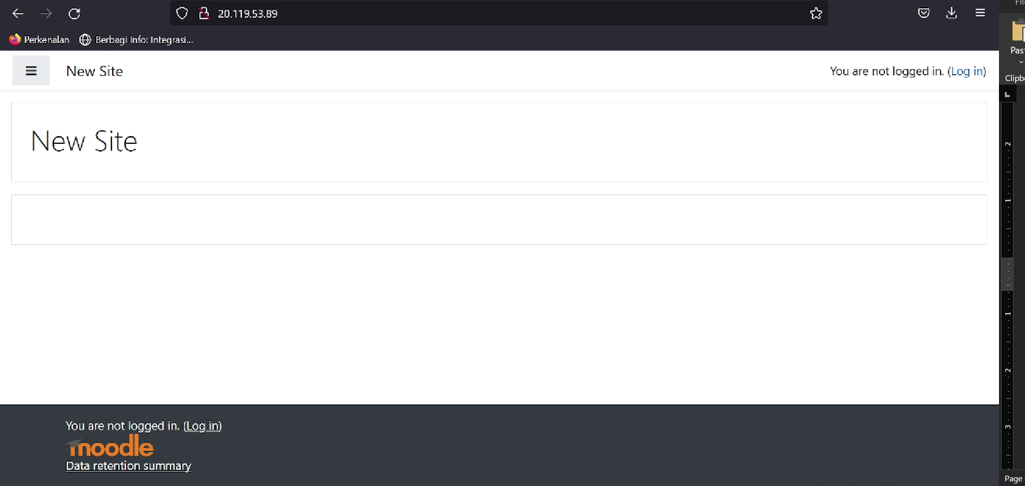

**STEP 4:**

* Dapat memilih salah satu cara dibawah tapi saya memilih cara kedua yaitu menggunakan Niagahoster dikarenakan saya sudah memiliki domain sendiri dan sudah menggunakan SSL Certificate untuk keamanan yang nantinya di mapping ke Public IP Address.

**SETTING CUSTOM DNS THROUGH AZURE APP SERVICE DOMAINS**

* Pilih ‘Create a Resource’ di Halaman Home Azure Portal
* Lalu, cari di Search Box ‘App Service Domain’
* Pilih ‘Create’ pada halaman App Service Domain
* Recommended Configuration:

|  |  |
| --- | --- |
| **BASICS** | |
| **Project Details** | Select a subscription to manage deployed resources and costs. Use resource groups like folders to organize and manage all your resources. |
| Subcription | **Azure Free Student** |
| Resource Group | MariBelajar-RG – Already Exist |
| **Domain Details** | Enter a domain name and select it from the list. If you don't see the domain you entered, it's not available. All domains shown here are available for $11.99 USD each per year. |
| Domain | My domain: maribelajar.biz |
| **CONTACT INFORMATION** | |
| **Personal Information** |  |
| First Name | Your first name |
| Middle Name | Your middle name |
| Last Name | Your Last Name |
| Organization | Where do you job or study? |
| Job Title | What’s your Job Title? |
| Email | Your email |
| Confirm Email | Confirm Your Email |
| **Phone and Address** |  |
| Country Code | Indonesia (+62) 🡪 Your Code Phone Number |
| Phone | Your Phone Number |
| Address 1 | Your Address (Home, Work, etc.) |
| Address 2 | Your Alternative Address |
| Country | Where’s Country do you live? |
| State or Territory | Wheres’s your nationstate, province do you live? |
| City | Your City |
| Postal Code | Your Postal Code |
| **ADVANCED** | |
| **Auto Renewal** | Auto renew prevents untimely expiration and unexpected loss of your domain. You'll be charged annually automatically. |
| Enable Auto Renewal | Default (Disable) |
| **Privacy Protection** | Privacy protection ensures that your domain registration contact information in the WHOIS database will not be made public. There's no extra charge for privacy protection. |
| Enable Privacy Protection | Default (Enable) |
| **TAGS** | |
| Name | MariBelajar |
| Value | Learning Management System |
| Resource | App Service Domains |
| **REVIEW AND CREATE** | |
| Review before klik Create. If Validation Passed, you can next to the next step. Klik CREATE. | |

* Setelah itu, kalian dapat memasukkan Record Set untuk menghubungkan dengan Public IP Address dan

**SETTING CUSTOM DNS & SSL THROUGH DNS PROVIDER “NIAGAHOSTER” – I HAVE MY OWN DOMAIN DAN HOSTING.**

* Pergi ke alamat <https://www.niagahoster.co.id> dan kemudian login ke akun kamu yang sudah memiliki layanan hosting dan domain.
* Klik “MemberArea” dan pilih menu ‘Layanan Anda’
* Pilih ‘Domain’
* Klik ‘Manage Domain’ atau ‘Kelola Domain’
* Scroll ke kanan 🡪 Pergi ke ‘DNS Management’
* Add Record dan jangan lupa copy ‘Public IP Address’ dari Halaman Overview ‘MariBelajar-VM’ dan Paste pada IPV4 di Record Column
* Kamu dapat menambahkan sub-domain atau menggunakan domain utama mu untuk moodle mu
* Kemudian ‘Save Record’
* Selanjutnya, pergi ke ‘Domain Forwarding’ disebelah ‘DNS Management’.
* Jangan lupa copy ‘DNS Name Label Records’ dari Halaman Overview ‘MariBelajar-VM’ dan Paste di DNS Forwading.
* Kemudian website mu bersifat Secure jika dalam domain kalian sudah menggunakan SSL secara otomatis. Jika kalian tidak memiliki hosting dalam domain anda. Anda dapat menggunakan CloudFlare untuk mendapatkan SSL Gratis.

**SETTINGS SSL THROUGH CLOUDFLARE**

* Sign Up ke CloudFlare
* Masukkan Domain kalian
* Masukkan A Record 🡪 pertama dengan nama @ dan kedua dengan nama WWW.
* Ubah Name Server di DNS Provider ‘Niagahoster’ di Domain kalian dengan Name Server yang kalian dapatkan di CloudFlare
* CloudFlare akan melakukan verifikasi dimana propagation 1 x 24 jam
* 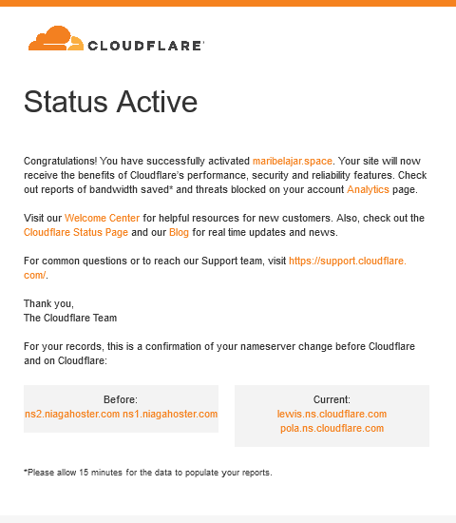Nanti akan muncul di email seperti ini jika sudah aktif:

**STEP 5:**

**LOGIN TO MOODLE SITE AND MANAGING YOUR SITE**

* Untuk Login ke dalam Moodle dan mengelola Website Moodle, kalian harus mengcopy + paste “Username dan Password” yang dapat didapatkan dibagian MariBelajar-VM di Azure Virtual Machine 🡪 Dari Overview MariBelajar-VM 🡪 Scroll ke bagian “Boot Diagnostic” di pilihan menu di kiri 🡪 Buka ‘Serial Log’ 🡪 lalu Cari Password dan Username. Untuk bentuknya seperti ini:

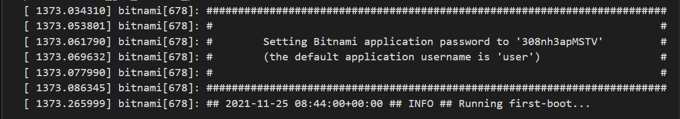

**REGISTER YOUR SITE**

* Saat pertama kali masuk sebagai **“Admin User”** dimana kita dipastikan untuk mendaftarkan Website kita ke Moodle,
* Masuk ke Site Administration
* Tampilan ‘**Register Your Site’** akan terbuka dan isi data dikolom yang disediakan lalu scroll dan “**Save Changes”**

**FORCE USERS TO LOGIN AND HIDE A GUEST BUTTON**

* **Moodle** menyediakan feature yang Namanya **“Force Users to Login”** artinya setiap memasukkan Website maribelajar.space maka akan menuju langsung ke Halaman Login dan meminta user untuk Login apabila tidak memiliki akun dapat mendaftarkannya. Selain itu, Moodle juga menyediakan feature **“Hide a Guest Button”** jadi, user external yang tidak memiliki akun tidak dapat sembarangan masuk.

**Force Users to Login**

* Login ke halaman **“Admin User” –** Notes: ***user and password from Boot Diagnostic***
* Site Administration 🡪 Security 🡪 Site Security Settings
* Force users to Log in (Default:No) **–**  ubah menjadi **‘YES’**
* Scroll ‘Save Changes’

**Hide a Guest Button**

* **Site Administration 🡪 Plugins 🡪 Authentication**
* Manage Authentication 🡪 Scroll ‘Guest Login Button’ (Default;Show) – ubah menjadi **Hide**
* Scroll ‘Save Changes’

**CHANGE TITLE IN FRONT PAGE FOR THE BETTER LOOKS**

**Moodle** menyediakan feature untuk mengubah judul halaman website yang ada di Halaman Login beserta di Halaman Site Home awal Website.

* Site Administration 🡪 Front Page 🡪 Front Page Settings 🡪Ubah **“Full Site Name”**. Juga bisa ditambahkan Summary tentang website kita.
* Scroll “Save Changes”.

[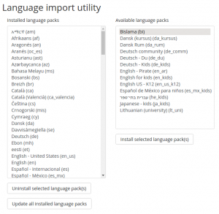](https://docs.moodle.org/311/en/File:installing_a_lang_pack.png)**ADDITIONAL LANGUAGE FOR MOODLE SITE**

**Moodle** menyediakan feature untuk menambah Bahasa ke Website kita yang nantinya dapat dipilih oleh Pengguna, jika Penggua ini menggunakan Bahasa yang berbeda seperti Bahasa Indonesia atau mungkin Bahasa Melayu, mereka dapat memilihnya. Sedangkan English sifatnya Default tidak dapat dihapus.

* Site Administration 🡪 Language 🡪 Language Packs
* Choose Language What You Want 🡪 Install Selected Language Packs
* If you want automatically using Another Language
* If Search Box – Type Language 🡪 Force Language – Choose Your Language you want and Scroll – Save Changes.

[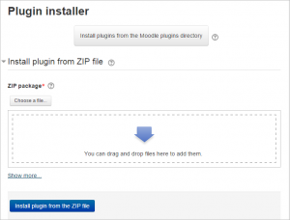](https://docs.moodle.org/311/en/File:plugin1.png)**ADDITIONAL PLUGINS**

**Moodle** menyediakan feature tambahan yang dapat digunakan dengan menginstalnya melalui Plugins seperti mengintegrasikan Microsoft Teams, Microsoft 365 dan Themes. Plugins dapat didownload di <https://moodle.org/plugins/> . Setelah mendownload sesuai versi moodle maka langsung dapat kita Install dengan cara: *Notes: Bitnami selalu Up-To-Date* jadi dapat dikatakan bahwa versi Moodle selalu terbaru.

**Installing Directly From The Moodle Plugins Directory**

* Login as an admin and go to Site administration 🡪 Plugins 🡪 Install plugins. (If you can't find this location, then plugin installation is prevented on your site.)
* Click the button 'Install plugins from Moodle plugins directory'.
* Select your current Moodle version, then search for a plugin with an Install button, click the Install button, then click Continue.
* Confirm the installation request
* Check the plugin validation report

**Installing via uploaded ZIP file**

* Go to the Moodle plugins directory, select your current Moodle version, then choose a plugin with a Download button and download the ZIP file.
* Login to your Moodle site as an admin and go to Administration 🡪 Site administration 🡪 Plugins 🡪 Install plugins.
* Upload the ZIP file. You should only be prompted to add extra details (in the Show more section) if your plugin is not automatically detected.
* If your target directory is not writeable, you will see a warning message.
* Check the plugin validation report

**CHANGE THEMES IN MOODLE WEBSITE**

* Site Administration 🡪 Appeareance 🡪 Theme 🡪 Themes Selector
* Change Theme 🡪 Pilih 🡪Use Theme (sesuai tema yang ingin digunakan) apabila ingin menambahkan tema dapat mendownloadnya menggunakan Plugins dan menggantinya di bagian Appeareance.

**CREATE USER OR UPLOAD DATABASE USER TO MOODLE**

* Site Administration – Menu User 🡪 Accounts 🡪 Upload Users 🡪 CSV Delimeter ; 🡪 Preview Row (20) 🡪 New user password (Field Required in File) 🡪 Force Password Change (None) 🡪 Default username No 🡪 Save Changes 🡪 Continue.

**CREATE COHORT -SEMACAM KELAS**

* Site Administration 🡪 Users 🡪 Account 🡪 Cohorts 🡪 Add New Cohorts

Nama : Microsoft Productivity Modern Workplace

Context : System

Cohort ID: MS-900

Description: Welcome to Microsoft Productivity – Modern Workplace! A Microsoft Modern Workplace is simply a Modern Workplace that uses Microsoft technology especially Microsoft 365. A Microsoft Modern Workplace leverages the latest Microsoft suite of tools to streamline and power key business operations. Microsoft’s suite of technologies is comprehensive and sophisticated. As well as being designed to facilitate the cultivation of a Modern Workplace. The Microsoft suite provides a central hub for key business operations, and establishes a hive-like system of interconnectivity. Which is both collaborative, and seamless. So, in this class, you will learn many things about capabilities of Microsoft 365 to reach your business goals and also developing your skill.

Nama: Cloud Fundamental

Context: System

Cohort ID: AZ-900

Description: Welcome to Cloud Fundamental! New to the Cloud? Cloud Fundamental is an opportunity to learn new things and increase your knowledge about cloud concepts, Azure services, Azure workloads, security and privacy in Azure, as well as Azure pricing and support. After take this course you will be able familiar with the general technology concepts, including concepts of networking, storage, compute, application support, and application development with Azure Capabilities to reach your business goals.

Nama: Data and AI

Context: System

Cohort ID: DP-900

Description: Welcome to Data dan AI! After take this course you will be able understand about how to use Capabilities of Azure Data and AI.

**CREATE CATEGORIES, COURSE AND ASSIGN ROLE TO MEMBER**

* Site Administration
* Courses 🡪 Manage Course and Categories 🡪 Categories ‘MariBelajar Member’ 🡪 Parent Name: TOP 🡪 ‘ MariBelajar Non-Member’ 🡪 Parent Name: TOP 🡪 **SAVE AND RETURN.**
* Pilih “Categories” yang sudah dibuat “Member MariBelajar” dan Pilih Create a New Cource

Course Full Name : Microsoft Productivity Modern Workplace

Short Name: MS900

Category : MariBelajar Member

Course Visibility: Show

Course Full Name : Cloud Fundamental

Short Name: AZ900

Category : MariBelajar Member

Course Visibility: Show

Course Full Name : Data and AI

Short Name: DP900

Category : MariBelajar Member

Course Visibility: Show

**ASSIGN COURSE TO STUDENTS**

* Klik **Course** yang ingin di Assign
* **Enroll Users**
* Select **Cohorts** untuk lebih cepat
* Assign as Students/Teacher

Untuk informasi lebih lanjut terkait mengelola site dapat melihat pada Laman Moodle yaitu di Dokumentasi Moodle <https://docs.moodle.org/311/en/Main_page> .